Normalization Exercise

1) Your task in this exercise is to move the un-normalized table to 3NF. To do this, use the dependency diagram.

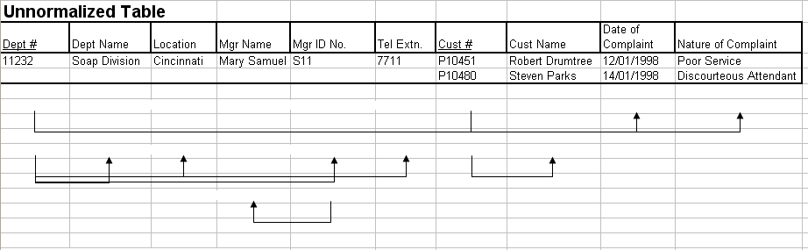

2. Given the Tables Below, Match them with the normalized form (NOT in 1NF, 1NF, 2NF, 3NF, BCDNF, 4NF, 5NF) they are in:

 | TABLE A |  |  |  |  |  | TABLE B
PatID | Name | PhysID |  | PhysName |  | PatID | Name | PhysName
54321 | Gore, A. | 12345 |  | Scholl, F. |  | 54321 | Gore, A. | Scholl, F.
43210 | Bush, G. | 23456 |  | Seuss, M. |  | 43210 | Bush, G. | Seuss, M.
32109 | Cheney, J. | 34567 |  | Doolittle, J. |  | 32109 | Cheney, J. | Doolittle, J.
21098 | Clinton, H. | 45678 |  | Spock, L. |  | 21098 | Clinton, H. | Spock, L.
10987 | Nader, R. | 23456 |  | Seuss, M. |  | 10987 | Nader, R. | Seuss, M.

 | TABLE C |  |  |  |  |  |  |  | TABLE D
PatID | Name | PhysID |  |  | PhysID | Name |  | PhysID |  | Name | PatID
54321 | Gore, A. | 12345 |  |  | 12345 | Scholl, F. |  | 12345 |  | Scholl, F. | 54321
43210 | Bush, G. | 23456 |  |  | 23456 | Seuss, M. |  | 12345 |  | Scholl, F. | 33445
32109 | Cheney, J. | 34567 |  |  | 34567 | Doolittle, J. |  | 12345 |  | Scholl, F. | 44556
21098 | Clinton, H. | 45678 |  |  | 45678 | Spock, L. |  | 23456 |  | Seuss, M. | 43210
10987 | Nader, R. | 23456 |  |  |  |  |  | 45678 |  | Spock, L. | 21098
 |  |  |  |  |  |  |  | 45678 |  | Spock, L. | 55667

 | TABLE E |  |  |  |  |  |  | TABLE F
PatID | Name | PhysID |  | RX Need |  |  | PhysID |  | Name | Specialty
54321 | Gore, A. | 12345 |  | Podiatry |  |  | 12345 |  | Scholl, F. | Podiatry
43210 | Bush, G. | 23456 |  | Pediatrics |  |  | 23456 |  | Seuss, M. | Pediatrics
32109 | Cheney, J. | 34567 |  | Veterinary |  |  | 34567 |  | Doolittle, J. | Veterinary
21098 | Clinton, H. | 45678 |  | Hynosis |  |  | 45678 |  | Spock, L. | Hynosis
10987 | Nader, R. | 23456 |  | Pediatrics

Employee and Projects
The table below depicts the requirements for a business consultancy working on local and international projects.
Emp-No | Emp-Name | Dept | Dept Manager | Proj-id | Proj-Start-Date | Location | Weeks-on-Project
005 | Smith | Marketing | Jones | A  B  C | 12-93  06-94  09-94 | Poole  Plymouth  Portsmouth | 11  15  6
007 | Bond | Accounts | Bloggs | B  D | 06-94  06-94 | Plymouth  Berlin | 3  9
009 | King | Info Systems | Hurne | C | 09-94 | Portsmouth | 10
010 | Holt | Accounts | Bloggs | A  B  D | 12-93  06-94  06-94 | Poole  Belfast  Hamburg | 21  10  12
Emp.no is the primary key. Employees work on a number of projects concurrently. Weeks-on-project represents the number of weeks that an employee has spent on a particular. The employee number, emp-no, and the project identifier, project-id, are unique identifiers. The department manager, manager, is the name of the current manager, i.e., there can be only one manager per department. A project can take place in several locations (i.e Employees can work on a project from their location). You are required to show the first, second and third normal forms.

